Lecture 29: Chapter 12: Exception Handling and Text I/O – Mon Dec 6
Announcements

Reading:
- Chapter 12 – Exception Handling and Text I/O

Assignments:
- Due: None

Today’s Goals
- Exception Handling Overview
- Exception Types
- More on Exception Handling
- The Finally Clause
- When to Use Exceptions
- Rethrowing Exceptions
- Chained Exceptions
- Defining Custom Exception Classes

Today's Terminology

Terminology
- Exception Handling
  - When a program is able to continue execution when a runtime error occurs

- Exception
  - Object that represents an error or condition that prevents execution from continuing normally
  - Instance of a class derived from java.lang.Throwable

- Unchecked Exception
  - RuntimeException and Error and their subclasses are known as unchecked exceptions
  - Generally unrecoverable programming logic errors
  - Compiler does not force programmer to catch

- Checked Exception
  - All other exceptions
  - Compiler forces the programmer to check and deal with exception or declare in method

- Throwing an Exception
  - The execution of a throw statement
  - Passing of an exception from place to another

- Chained Exception
  - When another exception is thrown along with an exception
  - A catch clause may need to “rethrow” original exception is one example
  - A new exception with more information may need to be thrown along with original exception

Exception Handling Overview

Example #1
- Write a program that meets the following:
  - Create an array with 100 randomly chosen integers
  - Prompt user for index of the array, then displays the corresponding element value.

import java.util.Scanner;

public class Chapter12 {

public static void main(String[] args) {

//Create an array with 100 randomly selected items
int[] data = new int[100];

// Initialize array
for (int i = 0; i < 100; i++) {
data[i] = (int)(Math.random() * 10000);
}

// Prompts user for index of an array element
// Display the value
Scanner input = new Scanner(System.in);
System.out.print("Enter an index: ");
int index = input.nextInt();

System.out.println("The element is " + data[index]);

} // main

} // Chapter12

- Run the program entering a valid index

Enter an index: 82
The element is 5528

- Run the program entering an invalid index

Enter an index: 100
Exception in thread "main" java.lang.ArrayIndexOutOfBoundsException: 100
at Chapter12.main(Chapter12.java:25)

- Code crashes!
- The code throws an exception because the array index is out of bounds
- Index needs to be in range of 0 - 99

Example #2 – Fix Issue with If Statement

public static void main(String[] args) {

//Create an array with 100 randomly selected items
int[] data = new int[100];

// Initialize array
for (int i = 0; i < 100; i++) {
data[i] = (int)(Math.random() * 10000);
}

// Prompts user for index of an array element
// Display the value
Scanner input = new Scanner(System.in);

System.out.print("Enter an index: ");
int index = input.nextInt();
One way to deal with possible error is using if statement
if (index >= 0 && index <= 99) {
System.out.println("The element is " + data[index]);
}
else {
System.out.println("Array index " + index + " is out of bounds");
}

} // main

- Run the program entering a valid index

Enter an index: 82
The element is 5528

- Run the program entering an invalid index

Enter an index: 100
Array index 100 is out of bounds

- Code does not crash!
- This approach might work just fine for your situation

What is Exception Handling
- When a program is able to continue execution when a runtime error occurs
- Runtime errors throw exceptions
- Examples:
  - division by 0
  - user enters a double when code expects an integer
  - array index out of bounds

System.out.println("The element is " + data[index]);

If index is not between 0 and 99 this
code throws an exception and currently crashes
- To use exception handling in your program , include try-catch blocks

try {
Code to run
Statement or method that may throw an exception
More code to run
}
catch (some exception) {
Code to handle the exception
}

Example #3 – Another Approach – Handle Array Index Out of Bounds with Exception Handling
- Add exception handling to code with try/catch block

import java.util.Scanner;

public class Chapter12 {
public static void main(String[] args) {

//Create an array with 100 randomly selected items
int[] data = new int[100];

// Initialize array
for (int i = 0; i < 100; i++) {
data[i] = (int)(Math.random() * 10000);
}

// Prompts user for index of an array element
// Display the value
Scanner input = new Scanner(System.in);

System.out.print("Enter an index: ");
int index = input.nextInt();

try { if an out of bounds
System.out.println("The element is " + data[index]); exception occurs here
} it is caught here
catch (Exception ex) {
System.out.println ("In catch clause!");
System.out.println("Array index " + index + " is out of bounds");
}
} // main
} // Chapter12

- Run the program entering fa valid index

Enter an index: 82
The element is 9542

- Run the program entering an invalid index

Enter an index: 100
In catch clause!
Array index 100 is out of bounds
Example #4 - Method that throws exception
- Here we move the code to a method to show how a method can throw an exception

public static void main(String[] args) {

//Create an array with 100 randomly selected items
int[] data = new int[100];

// Initialize array
for (int i = 0; i < 100; i++) {
data[i] = (int)(Math.random() * 10000);
}

// Prompts user for index of an array element
// Display the value
Scanner input = new Scanner(System.in);

System.out.print("Enter an index: ");
int index = input.nextInt();
Calling a method that can throw an exception
try {
int arrayValue = accessArray (data, index);
System.out.println("The element is " + arrayValue);
}
catch (Exception ex) {
System.out.println ("In catch clause!");
System.out.println("Array index " + index + " is out of bounds");
}

} // main

public static int accessArray (int[] data, int index) {
if (index >= 0 && index <= 99) {
return data[index];
}
else { If this exception is
throw new ArrayIndexOutOfBoundsException(); thrown it will be
} caught in the main
} try-catch block

Displays
Enter an index: 100
In catch clause!
Array index 100 is out of bounds

Notes
- throw new ArrayIndexOutOfBoundsException()
- This is called throwing an exception
- When this statement is executed it
  - Creates an object of the ArrayIndexOutOfBoundsException class
  - Then throws the exception – basically passes it to the caller of the method

Exception Types

Exception Types
- Exceptions are objects
- The root class for exceptions is java.lang.Throwable
- Java provides a number of predefined exception classes
  - Error
  - Exception
  - RuntimeException
  - ClassNotFoundException
  - NullPointerException
  - ArithmeticException
  - Etc.…

- User defined exceptions
  - Created by extending the Exception class or a subclass of Exception
  - Section 12.4

Class names for exceptions that occur at runtime

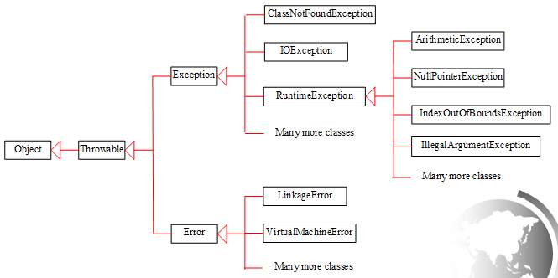

- Exception classes are classified into 3 major types
  - System errors
    - Thrown by JVM
    - Represented by Error class
    - Something bad happens to the run-time environment (internal system errors)
    - Serious run time problems that the user cannot usually do much, if anything about.
    - Examples:
        - OutOfMemoryError (anytime you use new, this could happen)
        - VirtualMachineError

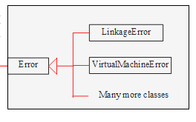
    - Exceptions
      - Represented by Exception class
      - Usually caused by the programmer, user, or external circumstances.
      - These run time errors can be caught and handled by your code

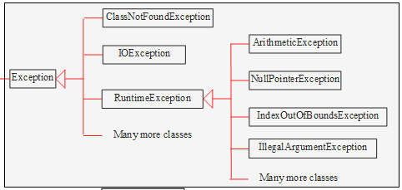

    - Runtime Exceptions
      - Represented by RunTimeException class – which is subclass of Exception
      - Usually caused by the programmer error.
      - Examples
        - Bad casting
        - Accessing array index out of bounds
        - Numeric errors

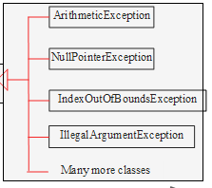

- Checked vs Unchecked Exceptions
  - Unchecked Exceptions
    - Error and RunTimeException and their subclasses
    - Programmer can choose to deal with or ignore
    - Mostly caused by programming logic errors and should be corrected in the code
    - Generally, don’t include try-catch blocks for these sort of issues
    - Example:
      - A for-loop that accesses an array element out of bounds will cause an ArrayIndexOutOfBoundsException
      - In this case, the for-loop code should be fixed.

  - Checked Exceptions
    - Any exception that is NOT an Error or RuntimeException
    - Programmer must deal with these using:
      - Try-catch block
      - Declare in method

More on Exception Handling

Exception Handling Requires
- Declaring an exception
- Throwing an exception
- Catching an exception

Declaring Exceptions
- A method
  - must state the types of checked exceptions it MIGHT throw
  - can state the types of unchecked exceptions it MIGHT throw
- This is called “declaring exceptions”
- To indicate a method MIGHT throw an exception, after the method’s parameter list and before open curly brace place the following:

throws typeOfException

Note the keyword is throws not throw

- Examples:

public static void main (…) throws IOException {

public static void openFiles () throws FileNotFoundException {

public static int accessArray (int[] data, int index)
throws ArrayIndexOutOfBoundsException, IOException {

Note: Best practice is to specify the most specific exception classes
even if you must specify multiple ones! It gives more info to caller.

Throwing Exceptions
- When errors are detected:
  - Create an instance of appropriate exception and
  - Throw it!
- This is called “throwing an exception”

if (index >= 0 && index <= 99) {
return data[index];
}
else {
throw new ArrayIndexOutOfBoundsException();
}

Note the keyword used here is throw

Catching Exceptions
- When a try-catch block is included in code this is called “catching exceptions”
- Setup the catch blocks to handle specific exceptions
- Catch blocks are called “exception handlers”

try {
System.out.println("The element is " + data[index]);
}
catch (IndexOutOfBoundsException ex) {
System.out.println("Array index " + index + " is out of bounds");
}
catch (Exception ex) {
System.out.println("Something else is wrong");
}

How Exception Handling Works
- When no exceptions occur:
  - If code contains try-catch blocks, code in try blocks execute and catch blocks are skipped

- When an exception occurs, here is what happens:
  - If offending code is not embedded in a try-catch block (not caught in current method)
    - Exception is passed to calling code

    - If the caller did not embed the method call in a try-catch, the above step is repeated until
      - Exception is caught or
      - Exception is passed to main

    - If reach main and if the call is not embedded in a try-catch block
      - Program halts (crashes)
      - Trace of the method calls, the exception type, and its error message is printed

Exception in thread "main" java.lang.ArrayIndexOutOfBoundsException: 100
at Chapter12.main(Chapter12.java:44)

  - If offending code is embedded in a try-catch block
    - Java searches the catch blocks, in order, for matching exceptions.
      - The search process starts in current method
      - If no matching catch in current method, then works backwards through method calls to find the matching exception handler
      - At each point, Java determines if the type of the exception object that was thrown is an instance of the exception in the catch blocks

    - The first matching catch is executed to handle the exception.

    - After first matching catch is executed, the program restarts after the try-catch block.
      - The rest of the try block is skipped

    - If no exceptions occur in a try-catch block, the catches are skipped.

    - An optional finally clause can be placed after ALL catches.
      - It is executed whether an exception occurs or not.

Notes
- Unchecked exceptions (system errors/runtime errors) can happen at any time so do not need to declare
- Visually

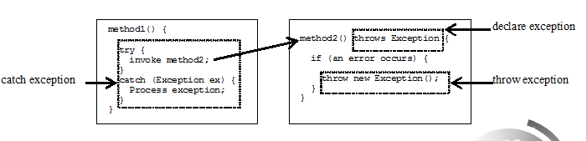

      - There is a hierarchy of exceptions!
        - Only one specific exception will be thrown
        - The exception will be a subclass of other exceptions.
        - A compiler error will occur if a catch block for an exception superclass (parent) occurs BEFORE an exception for a subclass (child).
          - Exception is the parent of IndexOutOfBoundsException
          - Exception needs to be “caught” in the last catch block!
          - This is a compiler error because Exception is before IndexOutOfBoundsException

try {
System.out.println("The element is " + data[index]);
}
catch (Exception ex) {
System.out.println("Something else is wrong");
}
catch (IndexOutOfBoundsException ex) {
System.out.println("Array index " + index + " is out of bounds");
}

        - Compiler error says:
    - Unreachable code block for IndexOutOfBoundsException. It is already handled by the catch block for Exception.

The Finally Clause

Finally
- A clause that is always executed whether an exception occurred or not
- Including a finally clause in a try-catch blocks

try {
Code to run
Statement or method that may throw an exception
More code to run
}
catch (some exception) {
Code to handle the exception
}
finally {
System.out.println ("This is always executed");
}

- 3 different cases
  - No exception occurs in try block
  - Exception occurs in try block and is caught in catch block
  - Exception occurs in try block and is NOT caught in catch block

In all 3 of these cases, the code in finally clause is execute!

Examples
- Assume we have the following code

System.out.print("Enter an index: ");
index = input.nextInt();

try {
System.out.println("The element is " + data[index]);
}
catch (Exception ex) {
System.out.println("Array index " + index + " is out of bounds");
}
finally {
System.out.println ("This is always executed");
}

System.out.println ("Done with try-catch block");

- No exception occurs in try block

Enter an index: 81
The element is 6710
This is always executed
Done with try-catch block

- Exception occurs in try block and is caught in catch block

Enter an index: 100
Array index 100 is out of bounds
This is always executed
Done with try-catch block

- Exception occurs in try block and is NOT caught in catch block
  - Changed code to catch NullPointerException

try {
System.out.println("The element is " + data[index]);
}
catch (NullPointerException ex) {
System.out.println("Array index " + index + " is out of bounds");
}
finally {
System.out.println ("This is always executed");
}

System.out.println ("Done with try-catch block");

  - Exception occurs, but it is not a NullPointerException so not caught by this catch clause
  - Finally executes
  - Exception is thrown out of main and programs crashes

Enter an index: 100
This is always executed
Exception in thread "main" java.lang.ArrayIndexOutOfBoundsException: 100
at Chapter12.main(Chapter12.java:44)

When to Use Exceptions

Using Exceptions
- Best to use try-catch blocks to deal with unexpected errors in your code
- Not ideal to use try-catch to deal with simple expected errors (logic errors)
- Do not abuse the use of exception handling – think if you really need to use before you do
  - Bad practice:
    - Using exceptions for control flow
  - Why:
    - Exceptions are essentially a goto statement
      - Goto statements are avoided or not even provide in languages because they make tracing control flow difficult
    - Make code less readable and less understandable which lead to code that is harder to modify
    - Most lanaguages provide control structures to solve problems
      - If statements, while loops
    - Can cause performance issues

Example
- 1st example we did today, this situation is handled best with an if-statement

System.out.print("Enter an index: ");
int index = input.nextInt();
In this situation best way to deal with possible error is using if statement
if (index >= 0 && index <= 99) {
System.out.println("The element is " + data[index]);
}
else {
System.out.println("Array index " + index + " is out of bounds");
}

Example
- This situation is handled best with a try-catch block

try {
// file operations - open, manipulate, close

PrintWriter output = new PrintWriter("File.txt");

}
catch (FileNotFoundException ex) {
System.out.println ("File was not found");
}
catch (IOException ex) {
System.out.println ("Found file but something else went wrong.");
}

Rethrowing Exceptions

Did not cover

Chained Exceptions

Did not cover

Defining Customer Exception Classes

Did not cover

